WorkHorse Printer: Frame Assembly

Frame Assembly

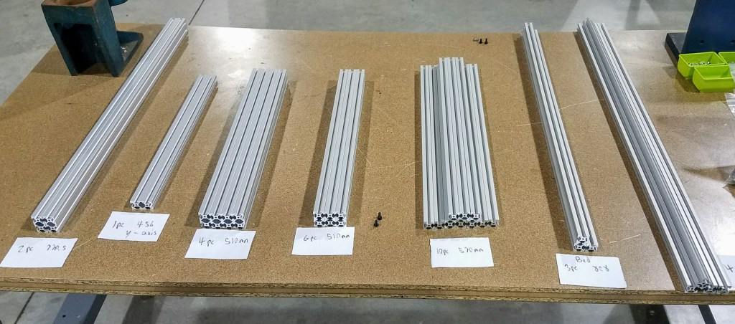Workhorse Frame Extrusions
The frame is made out of 2020 aluminum extrusions. We use Misumi profile but most 20mm x 20mm extrusion will work.:
20mm x 20mm HFS5 Aluminum Extrusions (Misumi Brand)
- 4pcs 930mm Long
- 6pcs 510mm Long
- 10pcs 570mm Long
- 3pcs 808mm Long
.
20mm x 40mm HFS5 Aluminum Extrusions (Misumi Brand)
4pcs 510mm Long

Frame: BOM

Frame Extrusions | Length | Units | Description | Part #
HFS5-2020 | 930mm Long | 4pcs | Horizontals | HFS5-2020-930
HFS5-2020 | 510mm Long | 6pcs | Verticals | HFS5-2020-510
HFS5-2020 | 570mm Long | 10pcs | Widths | HFS5-2020-570
HFS5-2020 | 808mm Long | 3pcs | Bed Support | HFS5-2020-808
Gantry Extrusions | Length | Units | Description | Part#
HFS5-2040 | 770.5 Long | 2pcs | Gantry Horizontals | HFS5-2040-770
HFS5-2040 | 456 Long | 1pcs
HFS5-2040 | 510 Long | 4pcs. | Z axis Linear Rail Verticals | HFS5-2040-510
Frame Components | Type | Units | Description | Part#
Frame Brackets | 20mm Wide | 90pcs | Reversal Tabbed Brackets | HBLFSNF5
Frame Brackets | M4 | 75pcs | M4 | HNKK5-4
Frame Brackets | M5 | 180pcs | M5 | HNKK5-5
Frame Brackets | M3 | 75pcs | M3 | HNKK5-3

Misumi Extrusions for Frame | Length | Units | Description | Part #
HFS5-2020 | 930mm Long | 4pcs | Horizontals | HFS5-2020-930
HFS5-2020 | 510mm Long | 6pcs | Verticals | HFS5-2020-510
HFS5-2020 | 570mm Long | 10pcs | Widths | HFS5-2020-570
HFS5-2020 | 808mm Long | 3pcs | Bed Support | HFS5-2020-808
Gantry Extrusions | Length | Units | Description | Part#
HFS5-2040 | 770.5 Long | 2pcs | Gantry Horizontals | HFS5-2040-770
HFS5-2040 | 456mm Long
HFS5-2040 | 510 Long | 4pcs. | Z axis Linear Rail Verticals | HFS5-2040-510
Frame Components | Type | Units | Description | Part#
Frame Brackets | 20mm Wide | 90pcs | Reversal Tabbed Brackets | HBLFSNF5
T-Nuts (Misumi) | M4 | 75pcs | M4 | HNKK5-4
T-Nuts (Misumi) | M5 | 180pcs | M5 | HNKK5-5
T-Nuts (Misumi) | M3 | 75pcs | M3 | HNKK5-3
Frame Price | Price $
Profile Extrusions | $ 122.29 |  | extrusions and brackets w/tax and shipping
M5 x 10 Cap Screws (200pcs) | $ 9.99 |  | 225$
brackets | $ 40.32
T-nuts | $ 19.32
Total | $ 191.92

Step 1
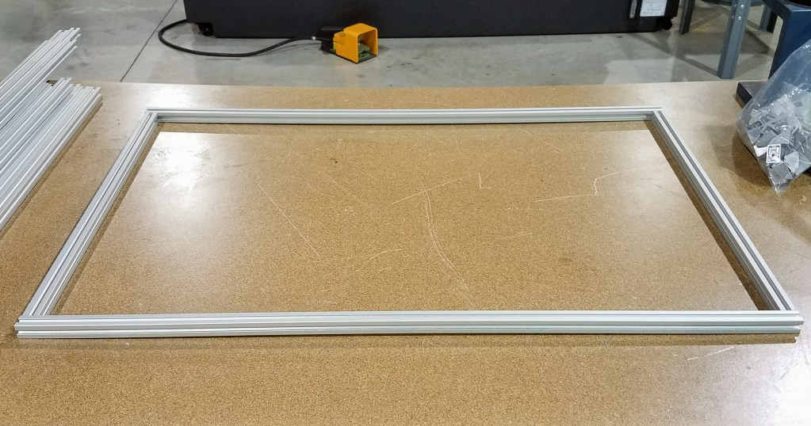

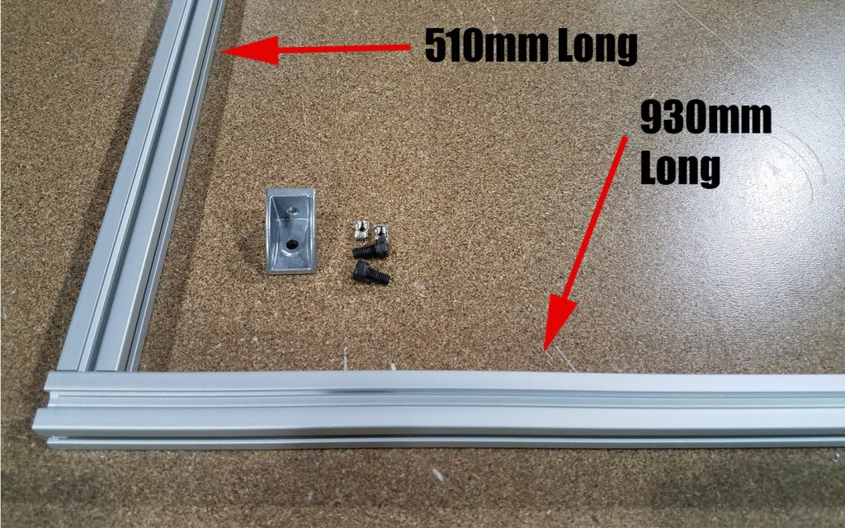

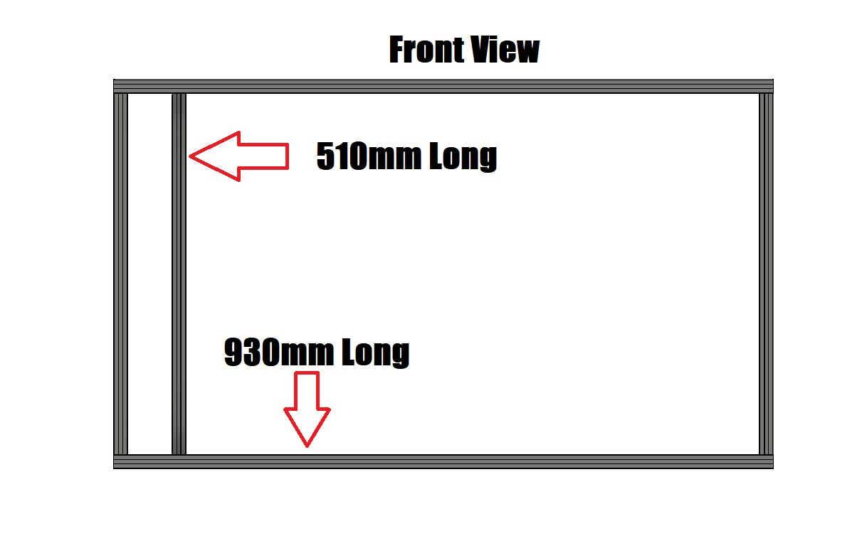

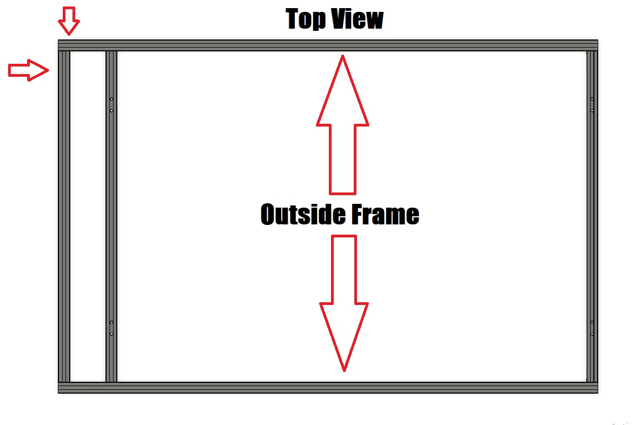

Watch Frame Assembly Video

Related Content
WorkHorse BOM
WorkHorse Frame
WorkHorse Motors
WorkHorse 3D Printer
3D Distributed
Frame Extrusions
Frame Assembly
Frame як

3d printer Frame Assembly

3D Printer frame parts

3D printer aluminum frame kit

3D printer frame only

Large 3D printer frame kit

3D printer frame kit

3D printer bare frame Kit

3D printer frame plans

How to build a 3D printer frame

3D printer frame material

DIY 3D printer frame

How to reinforce 3D printer frame

